# Työryhmä



(Get-WmiObject -Class win32_computersystem).workgroup

  
(Get-WmiObject -Class win32_computersystem).domain

(Get-WmiObject -Class win32_computersystem).partofdomain



(Get-WmiObject -Class win32_computersystem).name

# IP-asetukset



Haetaan tietokoneen IP-osoitteet ja sieltä tiettyä IP-osoitetta

Get-NetIPAddress -AddressFamily Ipv4 | Select-Object -Property InterfaceAlias, IPAddress | Where-Object IPAddress -eq "10.1.184.51"

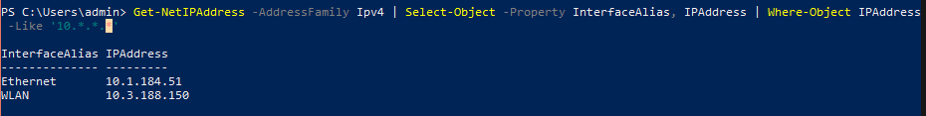

Tällä haetaan kaikki IP:t jotka alkaa 10. oktetillä, muut oktetit mitä tahansa.

Get-NetIPAddress -AddressFamily Ipv4 | Select-Object -Property InterfaceAlias, IPAddress | Where-Object IPAddress -Like '10.*.*.*'

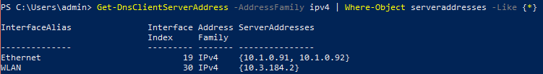

Get-DnsClientServerAddress -AddressFamily ipv4 | Where-Object serveraddresses -Like {*}

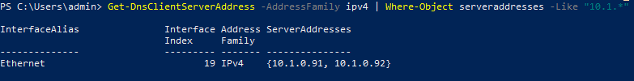

Get-DnsClientServerAddress -AddressFamily ipv4 | Where-Object serveraddresses -Like "10.1.*"

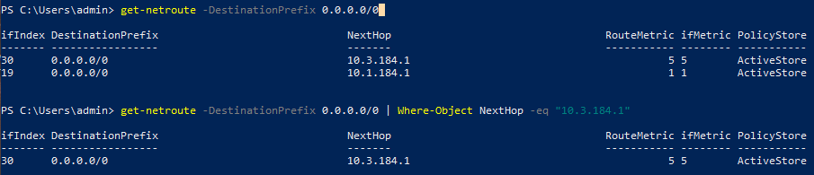

get-netroute -DestinationPrefix 0.0.0.0/0 | Where-Object NextHop -eq "10.3.184.1"



test-connection -quiet google.com

# Hyper-V

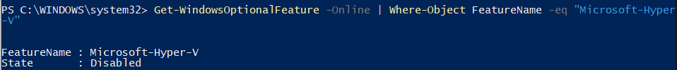

Get-WindowsOptionalFeature -Online | Where-Object FeatureName -eq "Microsoft-Hyper-V"

# Aktivointi



(Get-CimInstance -ClassName SoftwareLicensingProduct | where PartialProductKey).LicenseStatus

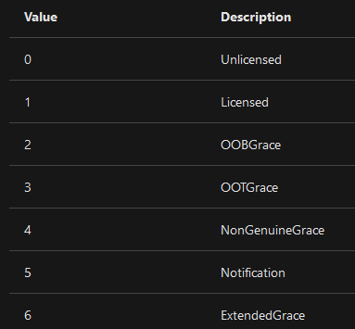

PowerShellistä administratoriksi:

